“Teens For Courage”

High-School Students United to Learn How to Shatter the Cycle of Intimate Partner Violence

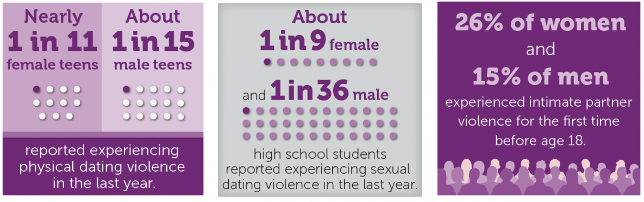

According to the National Resource Center for Domestic Violence, approximately 1.5 million high school students nationwide experience physical abuse from a dating partner. Research studies reveal that three in four parents never discuss the warning signs of intimate partner violence with their children. These alarming facts demonstrate that there is a significant need to raise awareness about healthy dating behaviors to prevent teen dating violence and abuse.

The Jamie Kimble Foundation for Courage is partnering with Mecklenburg County and Turning Point Services Inc., during Teen Violence Awareness Month, to provide a comprehensive educational curriculum to reinforce the development of healthy, respectful dating relationships. In addition, the eNOugh summit will provide students with an opportunity to network with one another and learn how to initiate or plan activities for a prospective or existing high-school based intimate partner violence club.

Schedule of Events
Venue: Carowinds Amusement Park
Date: Saturday, Feb. 1, 2020 at 9 a.m.

Want more information: info@jkffc.org

